Vale United Methodist Church

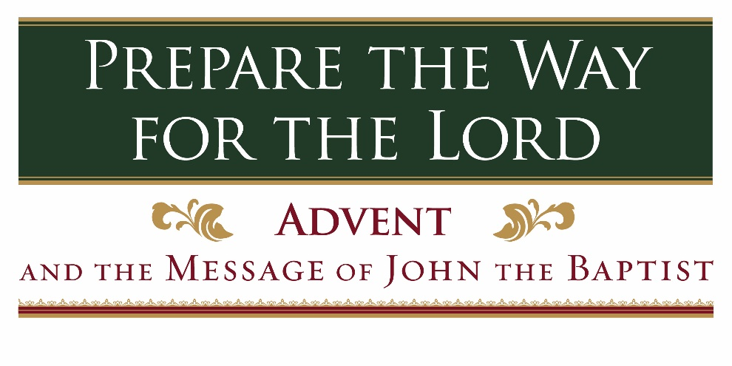

**“The Annunciation: God Has Heard Your Prayers”**

November 27, 2022

11528 Vale Road ⬪ Oakton, Virginia 22124

www.ValeChurch.org

In Person Worship at 10:00 a.m.

Virtual Worship at 8:30 a.m.

Facebook.com/groups/valechurch



1st Sunday in Advent November 27, 2022

“The Annunciation: God Has Heard Your Prayers”

GATHERING

We gather as the people of God to be formed by God’s grace.

**Welcome**

**The Peace**

*From your seat, please offer your neighbors the peace of Jesus Christ.*

*The liturgist will call out* ***“May the peace of Christ be with you!”***

*Please respond with,* ***“And also with you!”***

Prelude

**\*Call to Worship**

One: Look, I am sending my messenger who will clear the path before me.

**Many: We wait for you, Lord Jesus.**

One: The sun of righteousness will rise on those who revere my name.

**Many: We hope in you, Lord Jesus.**

One: Look, I am sending Elijah the prophet to you, to turn the hearts of parents to children and the hearts of children to their parents.

**Many: We wait for you. Come, Lord Jesus.**

*Hymn “My Soul Gives Glory to My God”

UMH 198

Lighting of the Advent Wreath

One: Advent is a time to be filled with anticipation and hope.

**Many: We wait and hope for the One who will bring light to the darkness.**

One: Advent is a time to remember that God’s love extends to all people.

**Many: We wait and hope for the One who will bring justice.**

One: Advent is a time to renew our determination.

**Many: We wait and hope for the One who will bring righteousness.**

One: Advent is a time to strive for understanding.

**Many: We wait and hope for the One who will bring peace.**

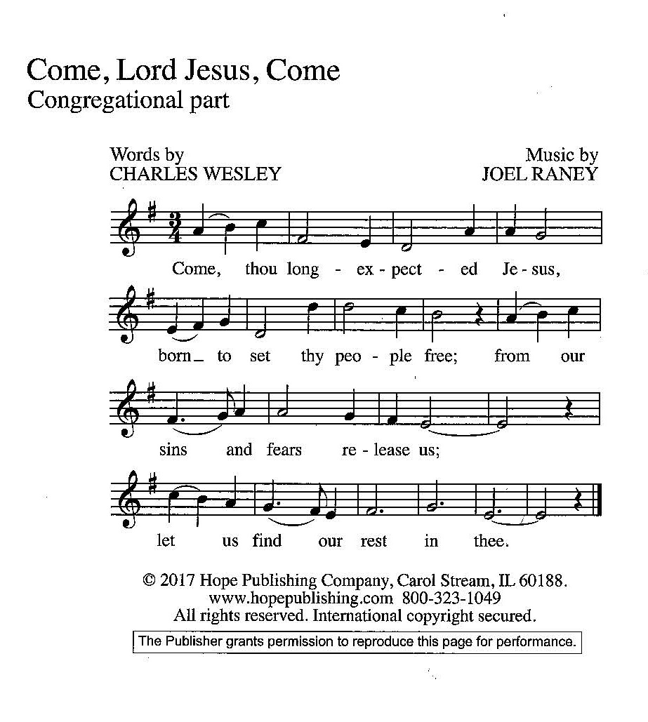

Confession and Pardon Lay Reader

**Many: Lord God, as we prepare our hearts and lives to receive you and welcome your son Jesus, we confess that we have sinned. We have strayed from your will. We have failed to do the things you have called us to do. We have acted without love and turned away from our neighbors in need. We repent. We turn back to you, God, and we want you to forgive our sins. Wash us and make us clean. Fill us with your spirit so that we may bear fruit worthy of repentance. We pray in the name of Jesus, the one who is coming. Amen.**

One: Hear the good news. The one who is coming is the Lamb of God, who takes away the sins of the world. He is the Messiah, the Savior, the Son of God, and the Light of the World. In the name of Jesus Christ, we are forgiven.

**Many: In the name of Jesus Christ we are forgiven! Thanks be to God! Amen and Amen.**

PROCLAMATION & RESPONSE

We hear God’s word proclaimed. We act in response.

Scripture Matthew 3:1-3

*The reading will end with* ***“A word of God that is still speaking.”*** *Please respond with* ***“Thanks be to God.”***

Children’s Moment

*After the Children’s Moment, children will be dismissed to their Sunday School class for the remainder of the service.*

Sermon

“The Annunciation: God Has Heard Your Prayers”

Rev. Jeff Haugh

Hymn “Come, Thou Long Expected Jesus”

UMH 196

**Call for Joys and Concerns**

Call to Prayer UMH 204

“Emmanuel, Emmanuel”

*Emmanuel, Emmanuel,*

*His name is called Emmanuel.*

*God with us, revealed in us,*

*His name is called Emmanuel.*

**Prayers of the People**

You may ask for prayer requests via chat. You also may

send prayer requests to **PrayerRequests@ValeChurch.org**.

After each petition, there will be a moment of silence closed by

“**Lord, in your mercy,”** Please respond with,

“**Hear our prayers.**”

**The Lord’s Prayer**

Our Father, who art in heaven,

hallowed be thy name.

Thy kingdom come,

thy will be done on earth as it is in heaven.

Give us this day our daily bread.

And forgive us our trespasses,

as we forgive those who trespass against us.

And lead us not into temptation,

but deliver us from evil.

For thine is the kingdom, and the power,

and the glory, forever. Amen.

*Doxology UMH 87

“What Gift Can We Bring”

*What gift can we bring, what present, what token?*

*What words can convey it, the joy of this day?*

*When grateful we come, remembering, rejoicing,*

*What song can we offer in honor and praise?*

**Blessing of the Offerings**

**\*Hymn “The King of Glory Comes” TFWS 2091**

SENDING FORTH

Transformed by God’s presence, we go into the world to serve.

**Announcements**

**\* Blessing and Charge**

**\* Postlude**

*\*Please stand in spirit or in posture.*

UMH – *United Methodist Hymnal*

TFWS – *The Faith We Sing Hymnal*

*License Information*

*CCLI*

*Copyright License 441761*

*Streaming License 20109494*

*One License*

*A-731934*

Thank you to Yvonne Lauw and Bill Tse for

providing our coffee hour treats!

Lay Readers:

10:00 Dorothy Arbiter

Virtual Suzanne Michaelis

Advent Wreath Lighters:

The Haugh Family

**Sermon Notes and Illustrations**

*This is a page for you to take notes on the sermon or for our children and youth to illustrate what they’ve heard in the story today.*

**NEXT SUNDAY IN WORSHIP**

2nd Sunday in Advent December 4, 2022

“Pregnancy, Birth, Circumcision, and Zechariah’s Prophesy”

Jeff Haugh

Masks are no longer required at Vale. Please wear a mask and maintain distancing if you are not up to date on vaccinations or boosters, if you are engaging with children, or based on personal preference, informed by personal level of risk.

This Week at Vale: Nov 27, 2022 – Dec 4, 2022

**Sun, Nov 27**

8:30 am Worship Service (Virtual)

8:45 am Contemporary Christian Topics

10:00 am Worship Service (In-Person)

**11:00 am Tree Sales\***

11:15 am Handbell Rehearsal

6:00 pm Youth Group

**Tues, Nov 29**

**6:00 pm Tree Sales\***

7:00 pm Wire Choir

**Wed, Nov 30**

**6:00 pm Tree Sales\***

7:30 pm Vale Chancel Choir

**Thurs, Dec 1**

**6:00 pm Tree Sales\***

**7:00 pm Trustees Meeting**

**Fri, Dec 2**

**6:00 pm Tree Sales\***

9:00 am Women’s Bible Study

**Sat, Dec 3**

**9:00 am Tree Sales\***

**Sun, Dec 4**

8:30 am Worship Service (Virtual)

8:45 am Contemporary Christian Topics

10:00 am Worship Service (In-Person)

**11:00 am Tree Sales\***

11:15 am Handbell Rehearsal

6:00 pm Youth Group

7:00 pm Sunday Evening Bible Study

*\* see announcement for details*

Vale Ministry Opportunities

Nov 27, 2022

WELCOME FRIENDS! WE’RE GLAD YOU’RE HERE!

Whether you are new to the area or a long-time resident, we warmly welcome you to our community of faith at Vale Church!

We look forward to meeting you in person—and hope to see you with us again soon!

Vale UMC is proud to be recognized as a Safe Haven congregation. If you suspect signs of human trafficking, please call 888.373.7888 or text 233733.

**Enjoy today’s message?** – Services can also be found on YouTube and Facebook by searching for “Vale United Methodist Church”. If you would like a DVD, please let us know.

**Church updates** – Did you know Vale sends out via email a weekly *Shout* and a monthly *Voice* with church updates? If you are **not** receiving our emails and would like to, please let the Vale office know.

**Do you want to support Vale's ministries?** Did you know that you can give to Vale online? We use the respected vendor Push Pay. You don't have to set up an account and you can designate your offering for a particular mission, program or for the general church funding. Go to <http://pushpay.com/g/valechurch> and see how easy it is. The information is confidential and secure.

If you have any questions or run into any difficulty using Push Pay, please contact our Financial Secretary, Bill Barnhart, at FinSec@ValeChurch.org

**Christmas Tree Truck 2 –** The second truck of trees is coming **TODAY, Nov 27**! We are expectingaround 800 trees, so we will need all hands on deck! Please sign up to help out with the link found at bit.ly/ValeChurchInfo.

**Christmas Trees are Here!** – The Christmas Tree sales have begun! Our lot is open M-F 6-9 pm, Sat 11am-9pm, and Sun 11am-5pm. Come help out with our biggest fundraiser of the year! A link to the SignUp Genius is available on bit.ly/ValeChurchInfo.

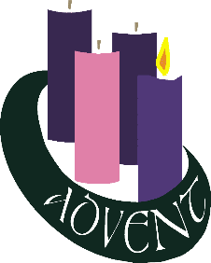**Advent Wreath Lighting –** Do you want to participate in worship this Advent season? We are looking for individuals and families to light our Advent wreath in both virtual and in person worship services. If you are interested, please contact either the office or Miranda Mason at [ChristianEd@valechurch.org](mailto:ChristianEd@valechurch.org).

**Advent Devotionals –** An Advent booklet of devotionals and daily service suggestions created by our Missions Committee are now available to be picked up in the office, or downloaded as a pdf from bit.ly/ValeChurchInfo.

**Advent Bible Study –** The Sunday Evening Bible Study group has started their Advent curriculum. For more information, contact Vic Larson at [larson.vic@gmail.com](mailto:larson.vic@gmail.com).

**Bloomin’ 4 Good** – For the entire month of December, **Vale’s Neighbors Feeding Neighbors program will receive $1 from every specially marked Bloomin' 4 Good bouquet sold at the Giant at 5740 Union Mill Rd. Clifton.**

**Chancel Choir** – WE WANT YOU - to join the Choir at Vale!! Everyone is welcome, and anyone can learn to sing. If you've ever had any interest in singing with a very friendly and loving group of people, now's your chance! Chancel Choir (ages 14-100) rehearsals are Wednesday evenings at 7:30 pm in the Sanctuary. Come and sing with us! Questions? Contact Jan Smith at [music@valechurch.org](mailto:music@valechurch.org).

**Wayne’s Corner** – As the Lay Leader for Vale, Wayne Applewhite acts as the connection between the congregation and the clergy. He invites you to email him at [applewhitew2003@yahoo.com](mailto:applewhitew2003@yahoo.com), or call at (703) 815-6618 with any matters you might want brought to Jeff

VALE CHURCH STAFF

Rev. Dr. Jeffrey Haugh, Pastor

Cell: 804-687-3938 /Pastor@ValeChurch.org

Loris Michaelis, Administrative Assistant

703-620-2594 /Office@ValeChurch.org

Miranda Mason, Director of Christian Education

703-620-2594/ChristianEd@valechurch.org

Susan Ricci, Director of Vale Preschool

703-620-2594 / Preschool@ValeChurch.org

Jan Smith, Music Director

703- 620-2594 / Music@ValeChurch.org

Norm Dietz, Accompanist/Organist

Vicky Alonzo, Nursery Caregiver

Olesya Ellis, Nursery Caregiver

Edilman Robles, Custodian

2022 VALE CHURCH LEADERSHIP

Tom Feeney, Council Chair • Susan Leigh, Secretary

Wayne Applewhite, Lay Leader • Bill Rigger, Finance Chair

Bill Barnhart, Financial Secretary • George Hohmann, Treasurer

Bette Rutherford, SPRC Chair • Kandi Molyneaux, Trustees Chair

TBD, Nurture Ministry Chair

Stephanie Marshall, Witness Ministry Chair

Linda Chrosniak, Outreach Ministry Chair

Dorothy Arbiter, Lay Member of Annual Conference

Rose Mangino, Lay Member of Annual Conference and

Youth Representative

Karen Leniart, United Methodist Women, President